Mehmet Izol

Professor Cleveland

COMP 3324-1 Computer Networks

Week 3 – Lab 1 – Sniffing UDP and TCP using Wireshark

February, 12, 2023

Sniffing UDP and TCP using Wireshark

1)DNS Lookup:  
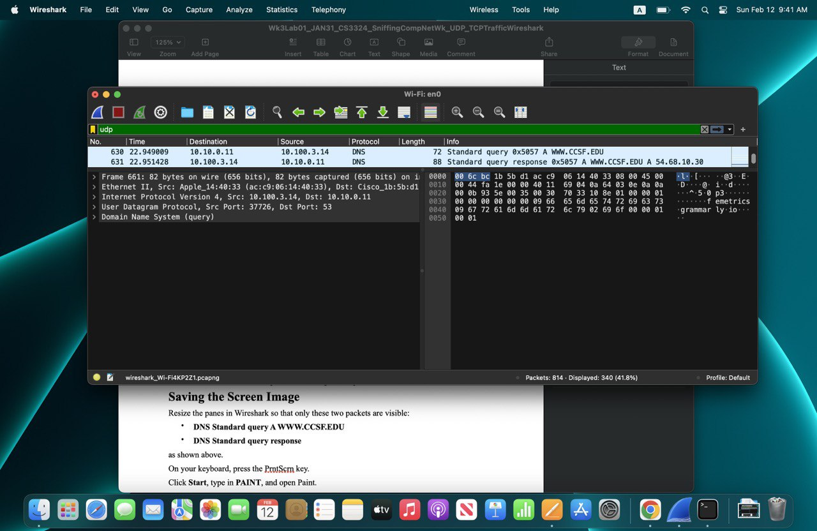

2) Capturing TCP Handshake

